11.
Code:
# Geographic Data
City <- c("City A",
"City B",
"City C")
Population <- c(500000,
700000,
600000)
Avg_Temperature <- c(75,
68,
80)
Elevation <- c(1000,
800,
1200)
geo <- data.frame(City,
Population,
Avg_Temperature,
Elevation)
print(geo)
plot(1:3,
1:3,
pch=19,
col="blue",
xaxt="n",
yaxt="n",
xlab="",
ylab="",
main="Geographic Distribution of Cities")

text(1:3,
1:3,
labels=geo$City,
pos=3)
plot(geo$Avg_Temperature,
geo$Population,
pch=19,
col="red",
xlab="Average Temperature",
ylab="Population",
main="Temperature vs Population")

abline(lm(Population ~ Avg_Temperature,
data=geo),
col="blue")
View(geo)
OUTPUT:
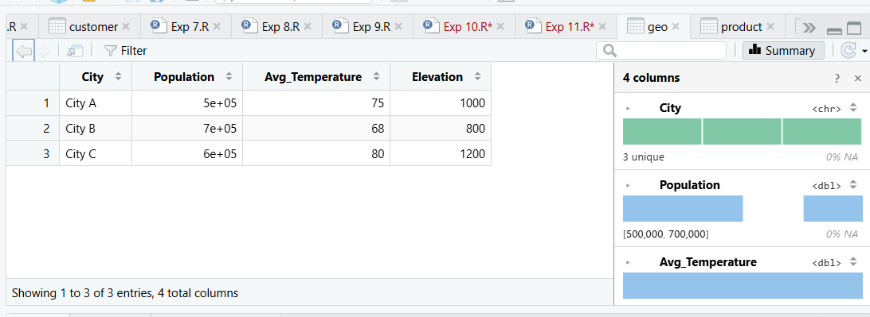
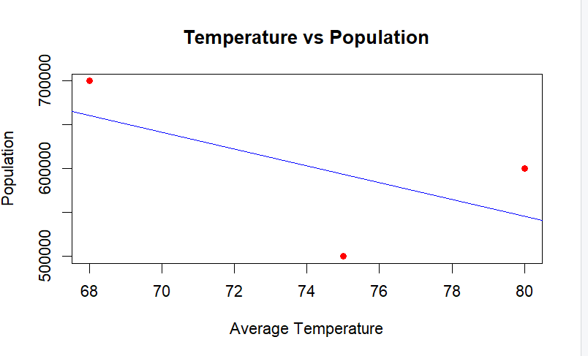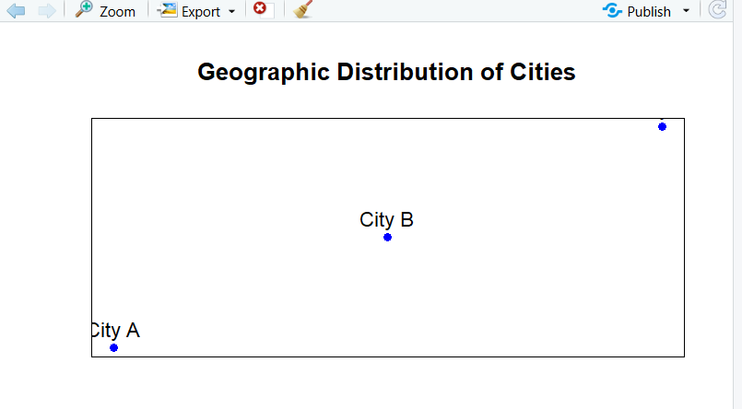
12.
Code:
# Product Inventory Dataset
Product_ID <- c(1,2,3)
Product_Name <- c("Product A",
"Product B",
"Product C")
Quantity_Available <- c(250,175,300)
Price <- c(20,15,18)
inventory <- data.frame(Product_ID,
Product_Name,
Quantity_Available,
Price)
print(inventory)
barplot(inventory$Quantity_Available,
names.arg=inventory$Product_Name,
main="Quantity Available for Each Product",
xlab="Product Name",
ylab="Quantity Available",
col="skyblue",
border="black")
inventory$Category <- c("Electronics",
"Electronics",
"Furniture")
inventory_table <- table(inventory$Category,
inventory$Product_Name)
barplot(inventory_table,
main="Quantity by Product Category",
xlab="Category",
ylab="Number of Products",
col=rainbow(nrow(inventory_table)),
legend.text=rownames(inventory_table))
View(inventory)
OUTPUT:
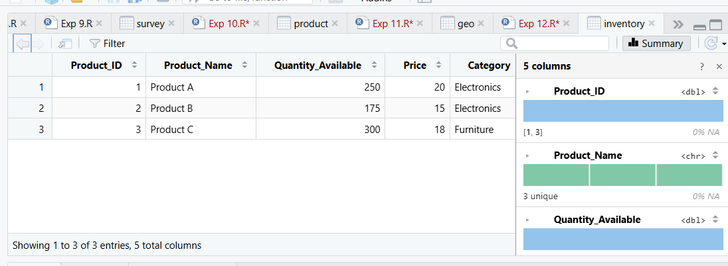
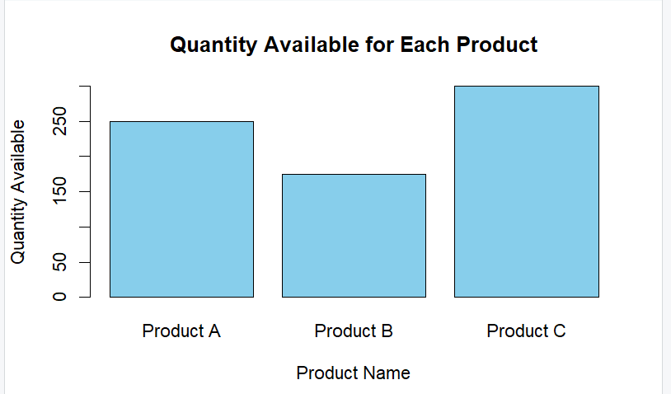
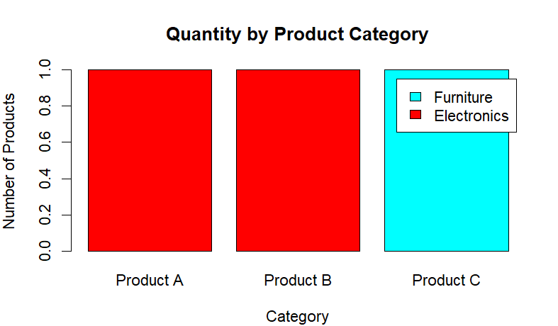
13.
Code:
# Stock Prices Dataset
Date <- c("2023-01-01",
"2023-01-02",
"2023-01-03")
Stock_A <- c(100,105,110)
Stock_B <- c(150,152,148)
Stock_C <- c(120,118,122)
stock <- data.frame(Date,
Stock_A,
Stock_B,
Stock_C)
print(stock)
plot(stock$Stock_A,
type="o",
col="blue",
xaxt="n",
ylim=c(90,160),
xlab="Date",
ylab="Stock Price",
main="Stock Prices Over Time")
lines(stock$Stock_B,
type="o",
col="red")
lines(stock$Stock_C,
type="o",
col="green")
axis(1,
at=1:3,
labels=stock$Date)
legend("topleft",
legend=c("Stock A","Stock B","Stock C"),
col=c("blue","red","green"),
lty=1,
pch=1)
percent_change <- c(0,
((105-100)/100)*100,
((110-105)/105)*100)
barplot(percent_change,
names.arg=stock$Date,
main="Daily Percentage Change of Stock A",
xlab="Date",
ylab="Percentage Change (%)",
col="orange",
border="black")
View(stock)

OUTPUT:
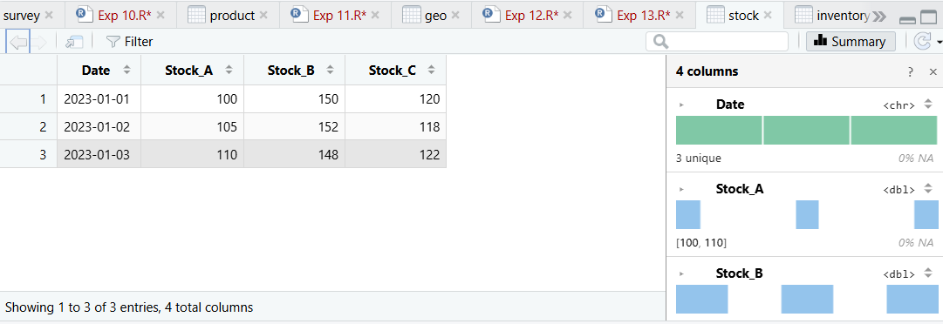
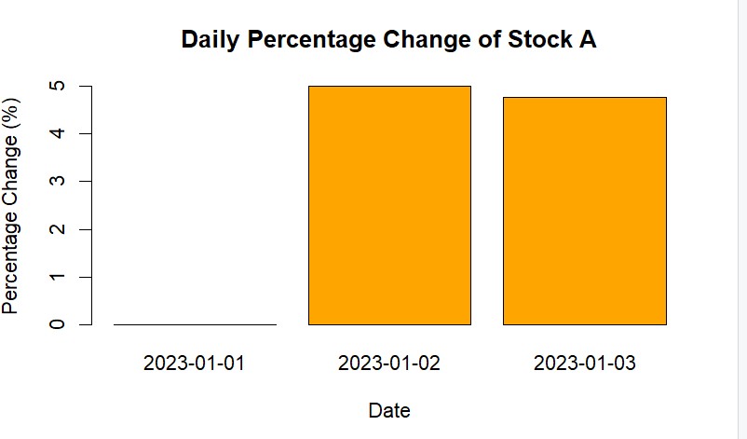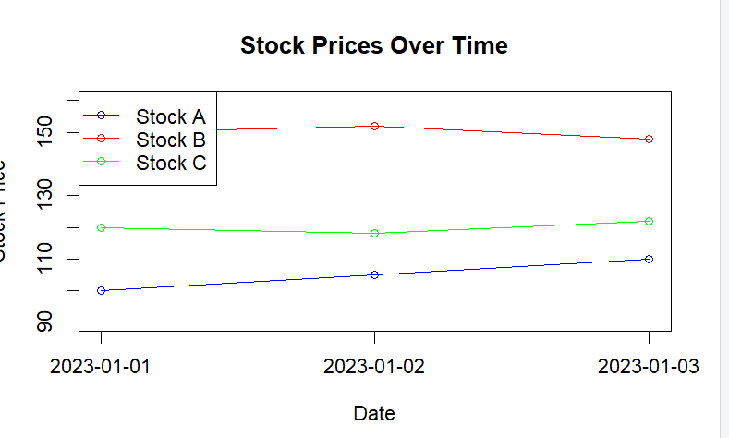
14.
Code:
# Energy Consumption Dataset
Sector <- c("Residential","Commercial","Industrial",
"Residential","Commercial","Industrial")
Region <- c("North","South","West",
"East","North","South")
Month <- c("Jan","Jan","Feb","Feb","Mar","Mar")
Temperature <- c(15,24,20,18,28,30)
Units_Consumed <- c(320,540,880,350,610,920)
Cost <- c(2100,3600,5900,2300,4100,6200)
Renewable_Usage <- c(22,18,12,25,20,15)
Peak_Hours <- c(4,6,8,5,7,9)
energy <- data.frame(
Sector,
Region,
Month,
Temperature,
Units_Consumed,
Cost,
Renewable_Usage,
Peak_Hours
)
print(energy)
hist(energy$Units_Consumed,
main="Distribution of Units Consumed",
xlab="Units Consumed (kWh)",
ylab="Frequency",
col="skyblue",
border="black")
plot(density(energy$Units_Consumed),
main="Density Plot of Units Consumed",
xlab="Units Consumed",
col="red",
lwd=2)
symbols(energy$Temperature,
energy$Units_Consumed,
circles=energy$Peak_Hours,
inches=0.3,
bg=rgb(0,0,1,0.4),
fg="blue",
xlab="Temperature (°C)",
ylab="Units Consumed (kWh)",
main="Temperature vs Units Consumed")
avg_usage <- aggregate(Renewable_Usage ~ Sector,
data=energy,
mean)
print(avg_usage)
barplot(avg_usage$Renewable_Usage,
names.arg=avg_usage$Sector,
main="Average Renewable Energy Usage by Sector",
xlab="Sector",
ylab="Renewable Usage (%)",
col=c("green","orange","skyblue"))
OUTPUT:
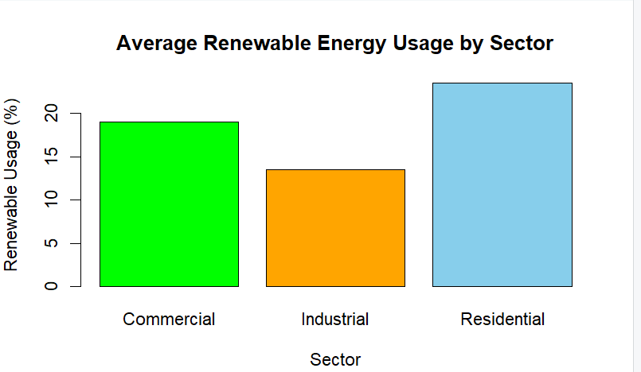
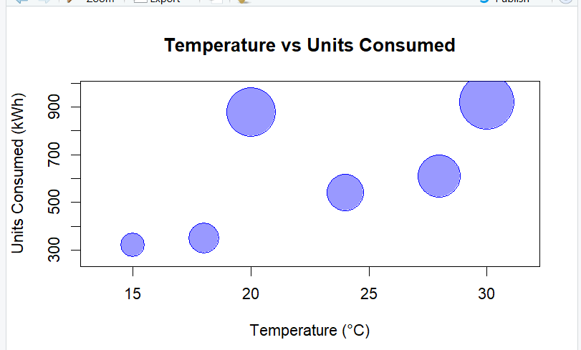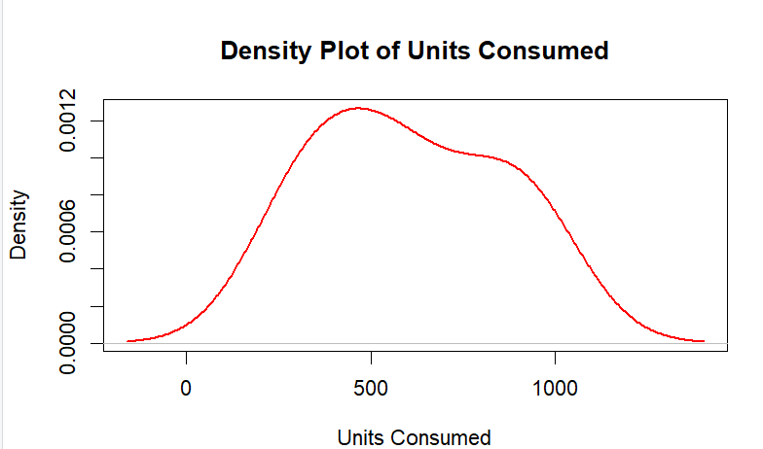
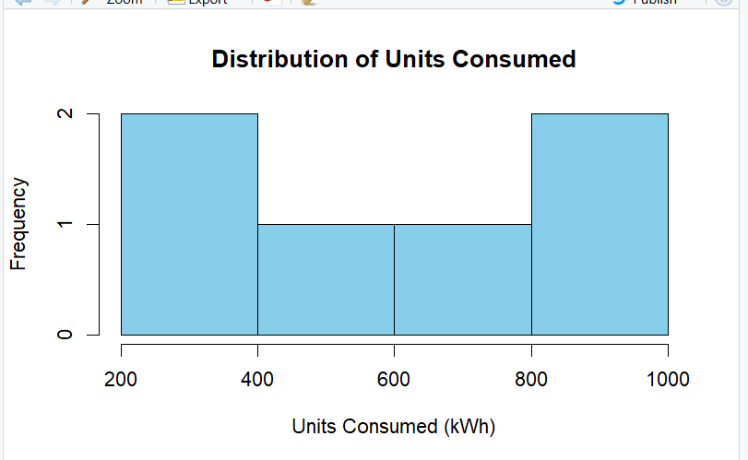

15.
Code:
# Student Mini Data
Student_ID <- c("S01","S02","S03","S04","S05","S06")
Gender <- c("Male","Female","Male","Female","Male","Female")
Study_Hours <- c(2.0,3.5,1.5,4.0,2.8,3.0)
Attendance <- c(78,90,70,95,85,92)
Math_Score <- c(62,80,55,90,72,82)
Science_Score <- c(65,85,58,92,74,86)
Exam_Date <- c("2025-01-10","2025-01-10",
"2025-02-12","2025-02-12",
"2025-03-15","2025-03-15")
student <- data.frame(Student_ID,
Gender,
Study_Hours,
Attendance,
Math_Score,
Science_Score,
Exam_Date)

print(student)
hist(student$Math_Score,
main="Distribution of Math Scores",
xlab="Math Score",
ylab="Frequency",
col="skyblue",
border="black")
plot(student$Study_Hours,
student$Math_Score,
col=ifelse(student$Gender=="Male","blue","red"),
pch=19,
xlab="Study Hours",
ylab="Math Score",
main="Study Hours vs Math Score")

abline(lm(Math_Score ~ Study_Hours,
data=student),
col="darkgreen",
lwd=2)

legend("topleft",
legend=c("Male","Female"),
col=c("blue","red"),
pch=19)
student$Exam_Date <- as.Date(student$Exam_Date)
student$Month <- format(student$Exam_Date,"%Y-%m")

avg_math <- aggregate(Math_Score ~ Month,
data=student,
mean)

print(avg_math)
plot(avg_math$Math_Score,
type="o",
xaxt="n",
col="blue",
xlab="Month",
ylab="Average Math Score",
main="Monthly Average Math Score")

axis(1,
at=1:nrow(avg_math),
labels=avg_math$Month)
OUTPUT:
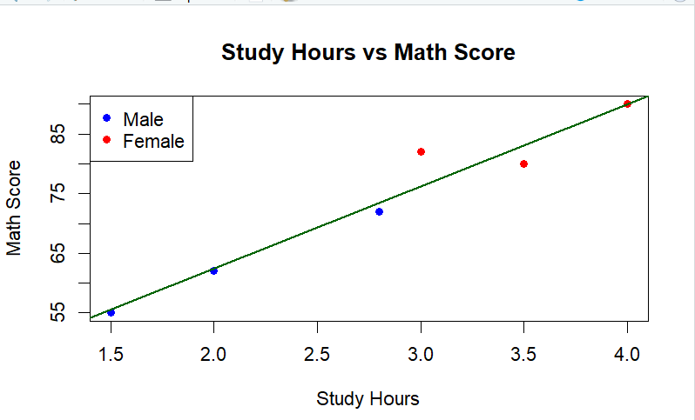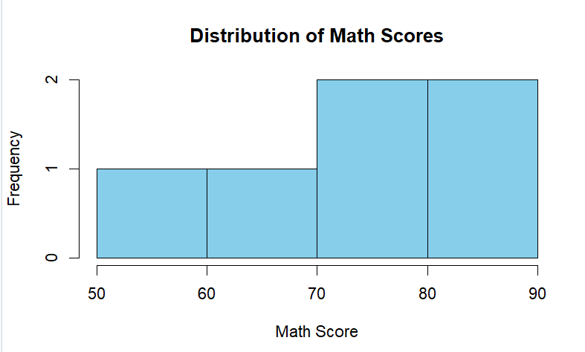
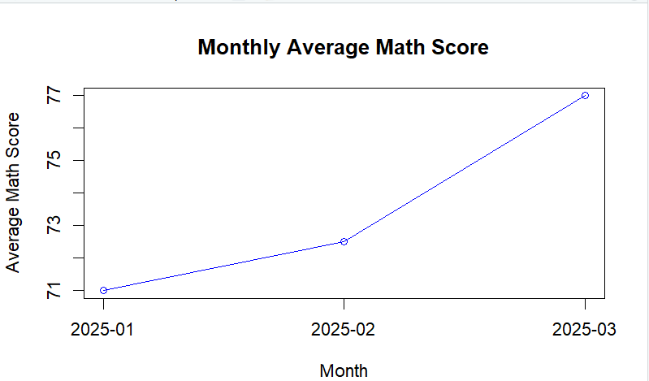
16.
Code: # Patient Health Risk Dataset
Patient_ID <- c("P1","P2","P3","P4","P5")
Age <- c(25,40,55,35,60)
BMI <- c(22,28,30,26,32)
BP <- c(120,135,145,130,150)
Cholesterol <- c(180,210,240,200,260)
patient <- data.frame(
Patient_ID,
Age,
BMI,
BP,
Cholesterol
)
print(patient)
pairs(patient[,2:5],
main="Scatterplot Matrix of Health Indicators",
col="blue",
pch=19)
plot(ecdf(patient$Cholesterol),
main="ECDF of Cholesterol Levels",
xlab="Cholesterol",
ylab="ECDF",
col="blue")
avg_values <- c(
mean(patient$Age),
mean(patient$BMI),
mean(patient$BP),
mean(patient$Cholesterol)
)

barplot(avg_values,
names.arg=c("Age","BMI","BP","Cholesterol"),
col=c("skyblue","orange","green","red"),
main="Average Health Indicators",
xlab="Health Indicators",
ylab="Average Value")
OUTPUT:
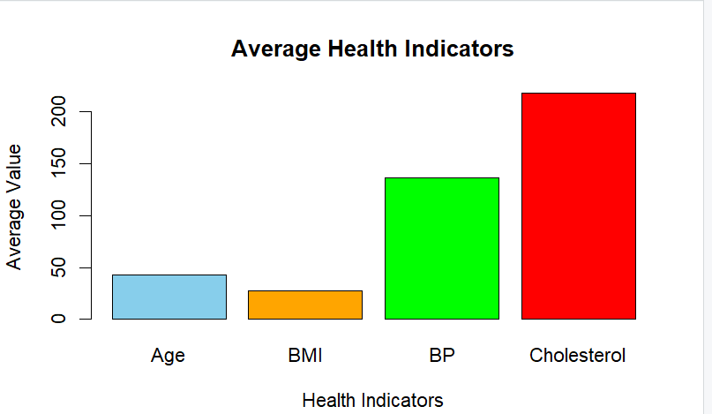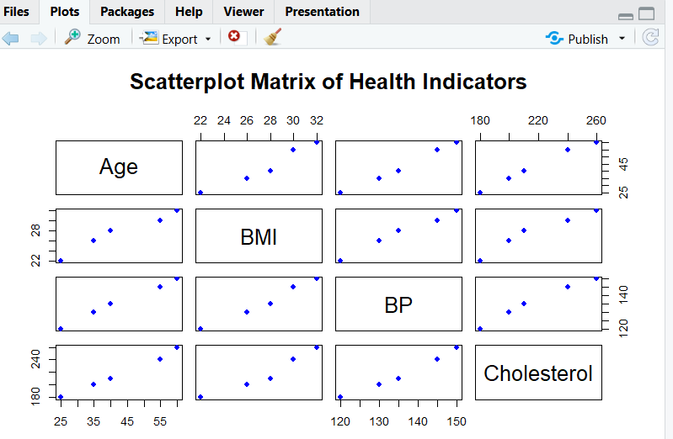
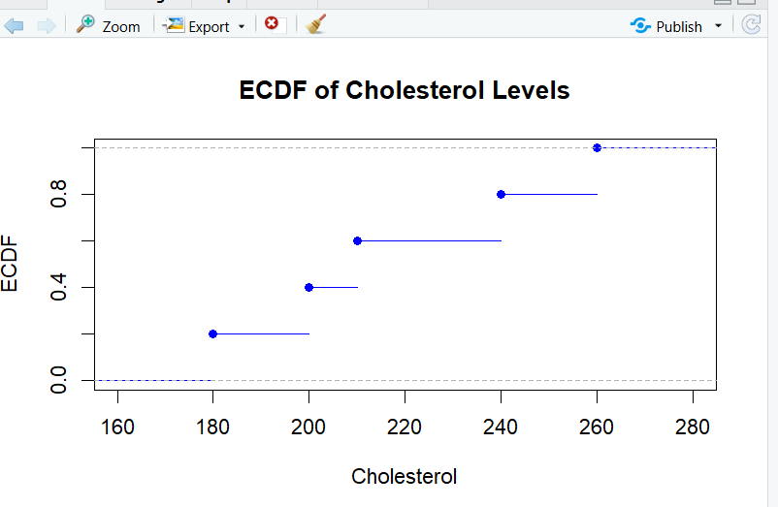
17.
Code:
# Vehicle Performance Dataset
Vehicle_ID <- c("V1","V2","V3","V4","V5")
Engine_Size <- c(1.5,2.0,3.0,2.5,1.8)
Horsepower <- c(110,150,250,200,130)
Fuel_Efficiency <- c(18,15,12,14,17)
Top_Speed <- c(180,200,250,220,190)
Safety_Rating <- c(4,5,5,4,3)
vehicle <- data.frame(
Vehicle_ID,
Engine_Size,
Horsepower,
Fuel_Efficiency,
Top_Speed,
Safety_Rating
)
print(vehicle)
# Install package (Only first time)
install.packages("ggplot2")

library(ggplot2)

ggplot(vehicle,
aes(x=factor(Safety_Rating),
y=Fuel_Efficiency,
fill=factor(Safety_Rating)))+
geom_violin(trim=FALSE)+
geom_boxplot(width=0.1,
fill="white")+
labs(title="Fuel Efficiency by Safety Rating",
x="Safety Rating",
y="Fuel Efficiency (km/l)")+
theme_minimal()
install.packages("corrplot")
library(corrplot)
vehicle_num <- vehicle[,2:6]
cor_matrix <- cor(vehicle_num)
corrplot(cor_matrix,
method="color",
addCoef.col="black",
tl.col="black",
tl.srt=45)
OUTPUT:
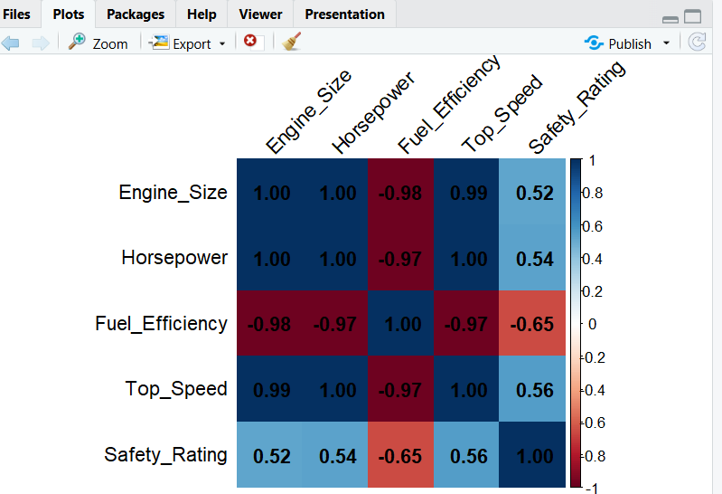
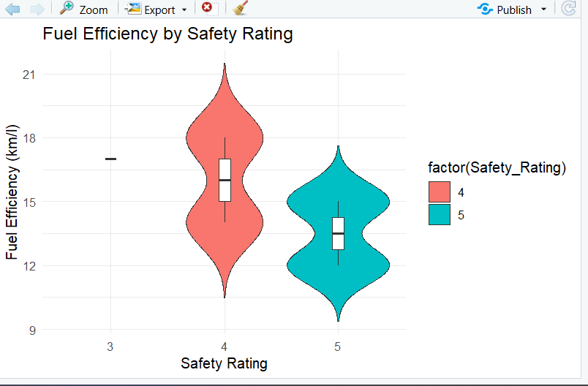
18.
Code:
# Student Academic Performance Dataset
Student_ID <- c("S1","S2","S3","S4","S5")
Age <- c(19,21,20,22,23)
Study_Hours <- c(12,8,15,10,7)
Attendance <- c(90,70,95,85,60)
Test_Score <- c(85,70,92,80,65)
Participation_Score <- c(8,7,9,8,6)
student <- data.frame(
Student_ID,
Age,
Study_Hours,
Attendance,
Test_Score,
Participation_Score
)
print(student)
x <- 1:5

test <- student$Test_Score
participation <- student$Participation_Score

plot(x,
test + participation,
type="n",
xaxt="n",
xlab="Students",
ylab="Scores",
main="Test Score and Participation Score")

axis(1,
at=1:5,
labels=student$Student_ID)

polygon(c(x,rev(x)),
c(rep(0,5),rev(test)),
col="skyblue",
border=NA)

polygon(c(x,rev(x)),
c(test,
rev(test+participation)),
col="orange",
border=NA)

legend("topleft",
legend=c("Test Score","Participation Score"),
fill=c("skyblue","orange"))
student$Attendance_Group <- cut(student$Attendance,
breaks=quantile(student$Attendance,
probs=seq(0,1,0.25)),
include.lowest=TRUE)

boxplot(Study_Hours ~ Attendance_Group,
data=student,
col=rainbow(4),
main="Study Hours by Attendance Quartiles",
xlab="Attendance Quartiles",
ylab="Study Hours")
plot(density(student$Test_Score),
main="Density Plot of Test Scores",
xlab="Test Score",
col="blue",
lwd=2)
OUTPUT:
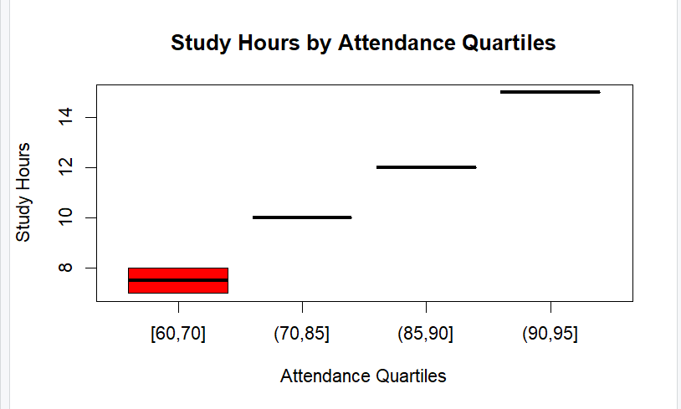

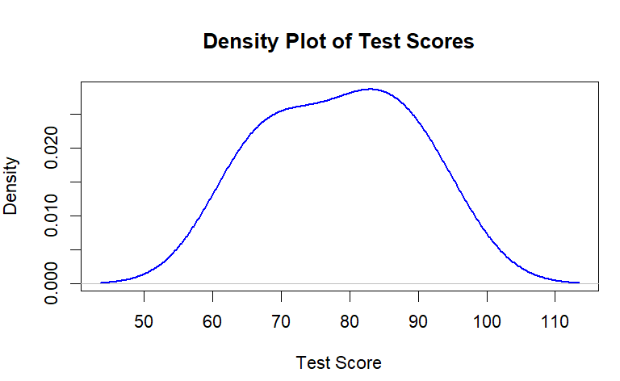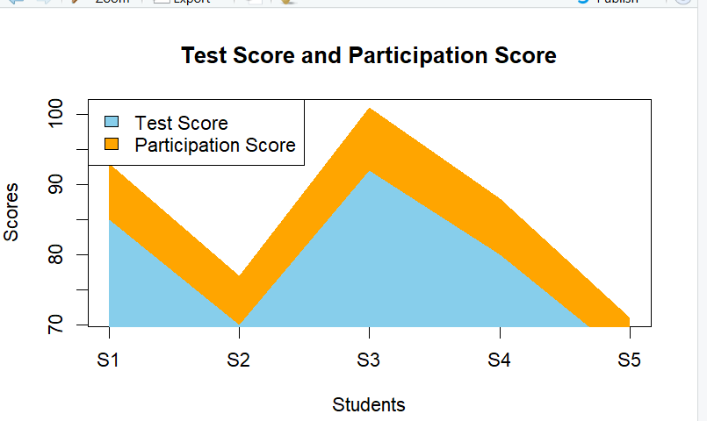
19.
Code:
# Mobile App Usage Dataset

User_ID <- c("U01","U02","U03","U04","U05","U06")
Gender <- c("Male","Female","Male","Female","Male","Female")
Age <- c(20,22,19,21,23,20)
Screen_Time <- c(4.5,6.0,3.2,7.1,2.8,5.4)
App_Usage_Count <- c(18,25,12,30,10,22)
Data_Used <- c(2.4,3.8,1.6,4.5,1.2,3.1)
Satisfaction <- c(3,5,3,5,2,4)
Usage_Date <- c("2025-01-08","2025-01-08","2025-02-11",
"2025-02-11","2025-03-14","2025-03-14")

mobile <- data.frame(
User_ID,
Gender,
Age,
Screen_Time,
App_Usage_Count,
Data_Used,
Satisfaction,
Usage_Date
)

print(mobile)
hist(mobile$Screen_Time,
main="Distribution of Screen Time",
xlab="Screen Time (Hours)",
ylab="Frequency",
col="skyblue",
border="black")
plot(density(mobile$Screen_Time),
main="Density Plot of Screen Time",
xlab="Screen Time",
col="red",
lwd=2)
plot(mobile$Data_Used,
mobile$Screen_Time,
pch=19,
col="blue",
xlab="Data Used (GB)",
ylab="Screen Time (Hours)",
main="Data Used vs Screen Time")

abline(lm(Screen_Time ~ Data_Used,
data=mobile),
col="red",
lwd=2)

cor(mobile$Data_Used,
mobile$Screen_Time)
OUTPUT:
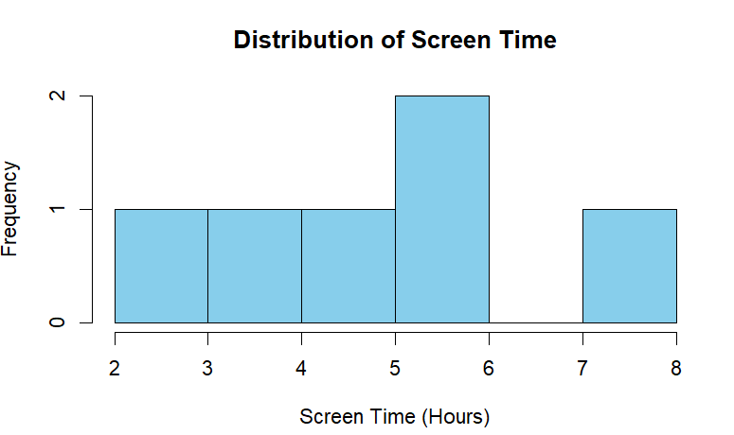
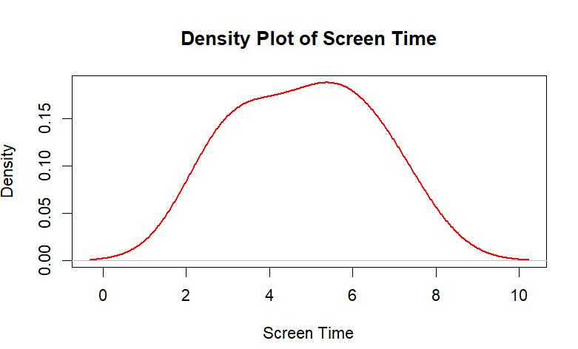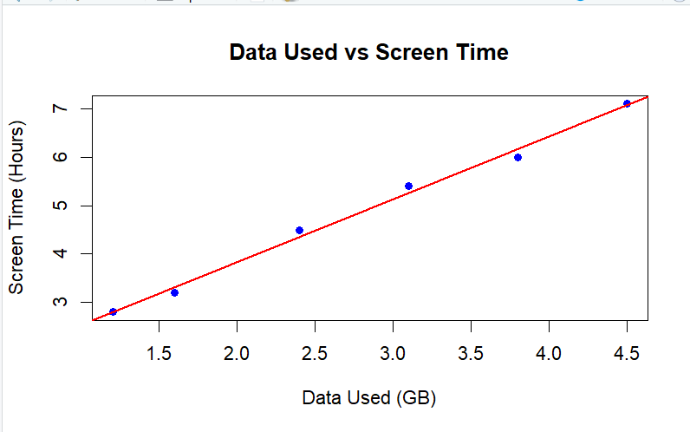
20.
Code:
# Step 1: Create Dataset
Patient_ID <- c(1,2,3,4,5)
Age <- c(25,40,35,50,29)
Waiting_Time <- c(2,5,1,7,3)
Appointment_Status <- c("Attended",
"Missed",
"Attended",
"Missed",
"Attended")

hospital <- data.frame(
Patient_ID,
Age,
Waiting_Time,
Appointment_Status
)

print(hospital)

# ============================================
# Task 1 : Histogram of Patient Ages
# ============================================

hist(hospital$Age,
main="Patient Age Distribution",
xlab="Age",
ylab="Frequency",
col="skyblue",
border="black")

# ============================================
# Task 2 : Pie Chart of Appointment Status
# ============================================

status <- table(hospital$Appointment_Status)

pie(status,
main="Appointment Status Distribution",
labels=names(status),
col=c("lightgreen","orange"))

# ============================================
# Task 3 : Bar Chart of Waiting Time
# ============================================

barplot(hospital$Waiting_Time,
names.arg=hospital$Patient_ID,
main="Waiting Time by Patient",
xlab="Patient ID",
ylab="Waiting Time (Days)",
col="pink",
border="black")

# ============================================
# Task 4 : Scatter Plot (Age vs Waiting Time)
# ============================================

plot(hospital$Age,
hospital$Waiting_Time,
main="Age vs Waiting Time",
xlab="Age",
ylab="Waiting Time (Days)",
pch=19,
col="blue")

abline(lm(Waiting_Time ~ Age,
data=hospital),
col="red",
lwd=2)
OUTPUT:
